

Indexing and Searching Document Collections using Lucene

Program Structure and Algorithms
Jyoti Sharma


Contents

Table of Contents
Contents 2
Abstract 4
Introduction 4
Background 4
Lucene Classes 4
Indexing 5
Searching 6
Analyzers 6
A Lucene index 7
Application Design 8
System configuration 9
Indexing various files using Apache Tika 13
Search Classes in Lucene 13
Scoring in Lucene (for Precision and Recall) 17
Steps to Run the Application 19
REFERENCES 20

Abstract

The amount of information available to a person is growing day by day; hence retrieving the correct information in a timely manner plays a very important role. This report talks about indexing document collections and fetching the right information with the help of a database(folder). The indexing of document collection is performed by Lucene, while the search application is strongly integrated with a database. In this report, a highly efficient, customized search tool is built using Lucene. The search tool is capable of indexing and searching databases, PDF documents, word documents, text files, html files, xml files, ppts, excel sheets, json files etc.

Introduction

The amount of information available to a human being is growing exponentially every day due to the advancement in technologies and the internet. The increased availability of documents in digital form has contributed significantly to the immense volume of knowledge and information available to people. Initially, the raw documents were given in various formats such as HTML, PDF, and WORD without following any schemas. They are called unstructured documents.
Due to their dynamic nature, fast growth rate, and unstructured manner, it is increasingly difficult to identify and retrieve valuable information from these documents. With the development in technology, various software products are available in the market. But Using off-the-shelf software products often promises a rapid system deployment. I have adopted an Apache open-source indexing toolkit, Lucene.
In my experiments, even though adopting Lucene was straightforward, integrating the Lucene indexing and the database querying were challenging. My implementation has illustrated a framework of integrating the full-scale text indexing engine Lucene with the database query techniques for a general approach of keyword search. This can be a very useful framework for many applications for small and middle businesses or organizations.

Background

Lucene Classes
Lucene consists of a set of key classes that are used to build a search application. The various key classes are given below:

IndexWriter – The IndexWriter class is used to create and maintain indices. This class also determines whether a new index is created or whether an existing index is opened for the addition of new documents.

Directory – The Directory class represents the location of a Lucene index. A Directory is a flat list of files. Files may be written once, when they are created. Once a file is created it may only be opened for read, or deleted. Random access is permitted both when reading and writing.

Document - The Document class represents a document in Lucene. Documents are the unit of indexing and search. A Document is a set of fields. Each field has a name and a textual value. A field may be stored with the document, in which case it is returned with search hits on the document.

Field - The Field class represents a section of a Document. The Field object will contain a name for the section and the actual data. Values may be free text, provided as a String or as a Reader, or they may be atomic keywords, which are not further processed. Fields are optionally stored in the index, so that they may be returned with hits on the document.

Analyzer - The Analyzer class is an abstract class that is used to provide an interface that will take a Document and turn it into tokens that can be indexed. There are several useful implementations of this class but the most commonly used is the Standard Analyzer class. A typical implementation involves building a tokenizer first, which breaks the stream of characters from the reader into raw tokens.

IndexSearcher - The IndexSearcher class is used to search through an index. This class implements a search over index reader.

Term - The Term is a basic unit for searching, consist of a pair of string elements, name of the field and he value of that field. A Term represents a word from text. Terms may also represent more than words from text fields, they can also represent things like dates, email addresses, URL’s, etc.

QueryParser - The QueryParser class used to build a parser that can search through an index. A Query is a series of clauses. A clause may be either a term, indicating all the documents that contain a term or a nested query enclosed in parentheses.

Query - The Query class is an abstract class that contains the search criteria created by the QueryParser.

Term Query – The term query class is used for matching documents that contain fields with specific values. This may be combined with other terms with a Boolean Query.

Hits - The Hits class contains the Document objects that are returned by running the Query object against the index. It is a ranked list of documents that is used to hold search results.

Indexing
The heart of all search engines is the concept of Indexing; Indexing in short can be defined as the processing of original data into a highly efficient cross reference lookup to facilitate rapid searching.

A Lucene index is stored in a single directory in the file system on a hard disk. The core elements of a Lucene index are segments, documents, fields, and terms. In a Lucene index, every index consists of one or more segments. Each segment contains one or more documents. Each document has one or more fields, and each field contains one or more terms. Each term is a pair of Strings representing a field name and a value. A segment consists of a series of files.

Pictorially the entire structure of a Lucene index can be represented as shown in figure

Searching
In Computer Science, searching can be defined as an algorithm that takes a problem as an input and returns a solution to the problem, usually after evaluating a few possible solutions.
The set of all possible solutions to a problem is called the search space.

Analyzers
Analyzers can be defined as components that pre-process input text. They are also used when searching. Because the search string has to be processed the same way that the indexed text is processed, it is crucial to use the same Analyzer for both indexing and searching. Not using the same Analyzer will result in invalid search results.
The Analyzer class is an abstract class, if there is a need to pre-process input text and queries in a way that is not provided by any of Lucene's Analyzers, one will need to implement a custom Analyzer.

Overview of Lucene Architecture and Lucene Applications

It is possible to add indexing and searching capabilities to any application using Lucene. It is possible to index and make searchable any data that can be converted to a text format. Lucene is independent of the source of data, its format, and even its language as long as it can be converted to text. This means one can use Lucene to index and search data stored in files, web pages, on remote web servers, documents stored in local file systems, simple text files, Microsoft Word documents, HTML or PDF files, or any other format from which one can extract textual information. The basic architecture of a Lucene application can be visualized as shown in figure

Lucene is an information retrieval (IR) library written purely in Java. Lucene provides the core API’s for adding full text indexing and searching functionalities for a given application; Hence Lucene is not a complete framework for implementing a search engine, as a matter of fact Lucene only helps the user with indexing and searching functions, more over to index any type of given data the data should be converted into text format as Lucene can only index text data and search with given user queries.
In the older search engines indexing is done by keywords and it is represented by text pairs determined by the user. Due to this type of design one should use Boolean queries for creating pairs (AND, OR, NOT). Lucene also supports Boolean queries term, range, prefix, phrase, wildcard and fuzzy queries.

A Lucene index
A Lucene index is an inverted index. An inverted index means that the content of the documents that are analyzed has their important terms indexed as a pair consisting of a field name and a field value. A field contains many terms that point to the corresponding documents. To summarize, an inverted index makes the process of retrieving documents from a system a breeze.
Finally, the documents are searched in the fields and in their values.
A Lucene index consists of many segments. A segment is created every time when new documents are created and indexed. Hence each segment has many documents stored in it. The documents consist of indexed Fields. An indexed field is a pair consisting of a field name and a field value pairs. Fields are used for calculating weights and ranking search results.

Application Design

My system facilitates the user with few aspects of functions:

- Collecting structured information including the course properties and short texts such as the title, abstract, description and audience. The user’s inputs are inserted into a table of the database.
- Collecting the unstructured information, mainly the course documents. These documents can be in plain text, PDF, HTML, or Word.
- Creating indexes for the unstructured documents. This is a critical step in providing keyword search with satisfactory response time.

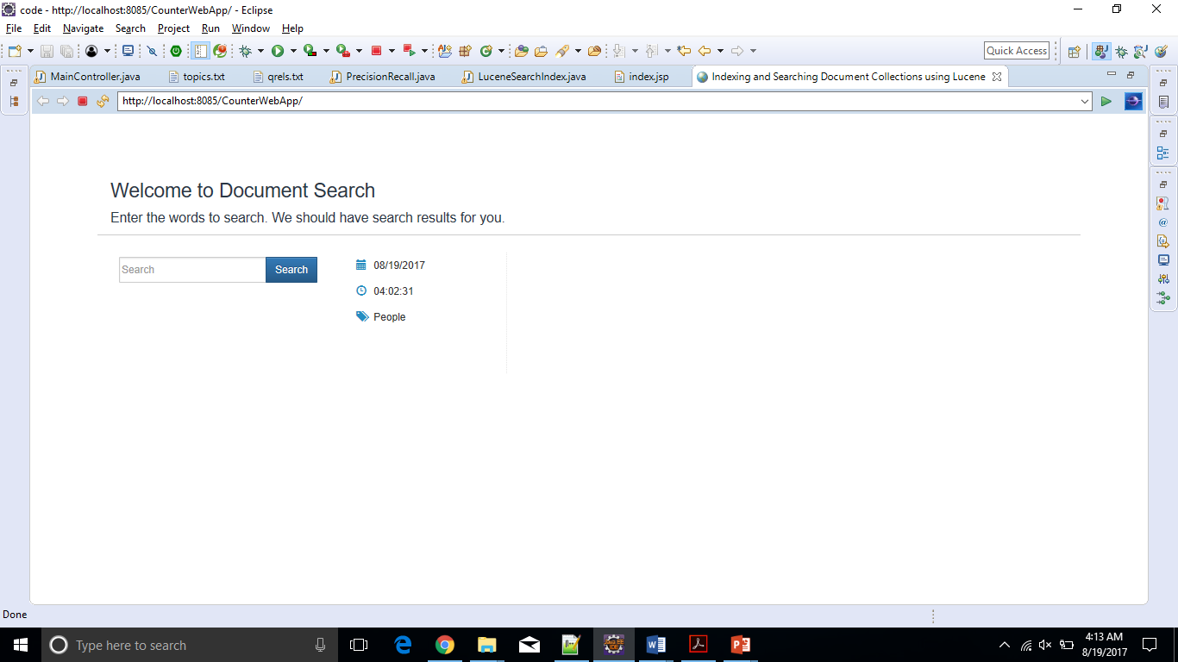

System configuration

This function is implemented as the system configuration GUI that provides the user an interface to enter the text to search for.

When multiple words can be given, the user should specify the logical operations, “OR”, “AND”, “NOT” between words. Lucene searcher can interpret Boolean queries effectively and perform logical operations on a set of key words. For examples, “A OR B” will return the documents which contains either word “A” or “B”. Similarly, “A AND B” will return the documents containing both words “A” and “B”. If “A NOT B” is given, then the documents which contain the word “A” but not the word “B” will be returned. Logical operations can also be grouped.

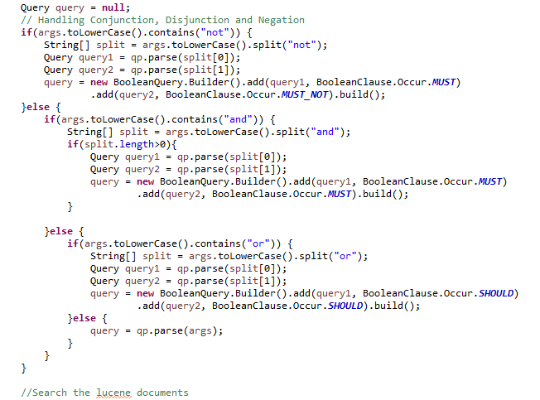

Lucene Index Classes
During the indexing process, there are five basic Lucene classes, they are the IndexWriter, Analyzer, Directory, Document, and Field IndexWrite. An IndexWriter creates and maintains an index. The IndexWriter takes an argument that determines whether a new index is created, or whether an existing index is opened for the addition of new documents.
Opening an IndexWriter creates a lock file for the directory in use. When we try to open another IndexWriter on the same directory will lead to an IOException. As a matter of fact, IndexWriter is the only class that has write-access to the index and using its methods one can add documents to the index for searching purposes.

Analyzer
An Analyzer builds TokenStreams, which analyze text. It thus represents a policy for extracting index terms from text. The analyzer discards text that is not useful for a searching application. Lucene has a number of analyzers some of them are BrazilianAnalyzer, ChineseAnalyzer, CJKAnalyzer, CzechAnalyzer, SimpleAnalyzer, SnowballAnalyzer, StandardAnalyzer, StopAnalyzer and a WhitespaceAnalyzer. The most generic and important analyzers are explained below:
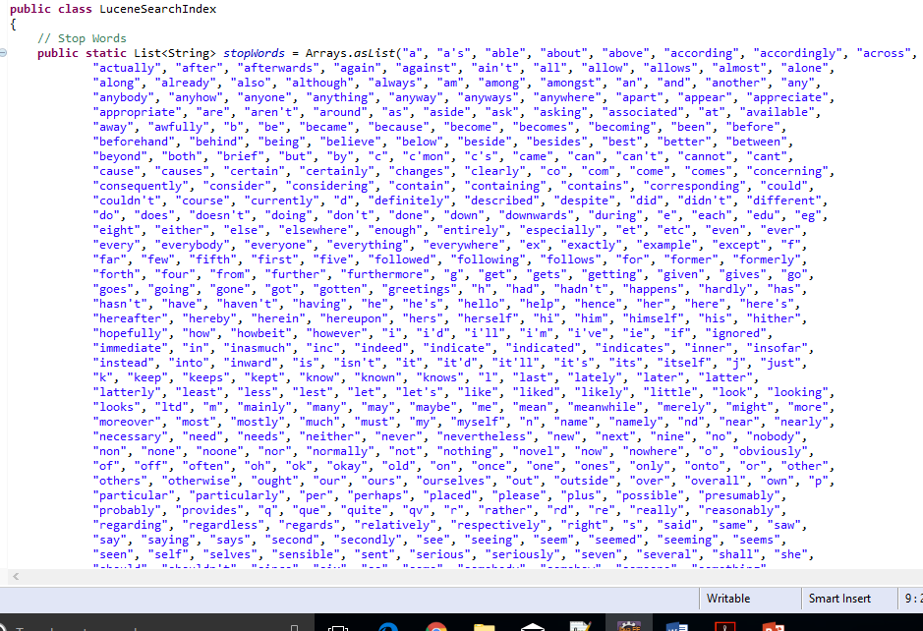

StandardAnalyzer
A StandardAnalyzer does both lower case and stop word filtering, and in addition it also tries to do some basic clean-up of words, for example taking out apostrophes (‘) and removes periods. The current application which is designed uses the StandardAnalyzer.

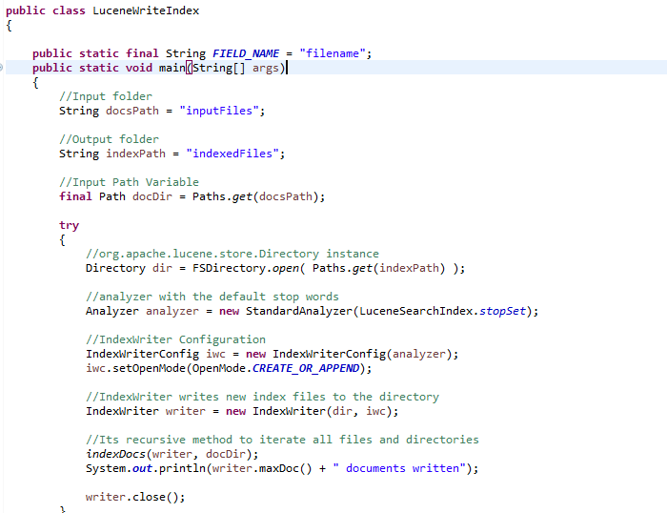

Directory
The Directory class represents the location of the index. It consists of FSDirectory and RAMDirectory classes. FSDirectory class stores the index in the file system while
RAMDirectory class stores the index in the memory. Because RAMDirectory does not write anything to the disk, it is faster than FSDirectory. However, since computers usually come with less RAM than hard disk space, RAMDirectory is not suitable for very large indices.

Document
Documents are the unit of indexing and search. A Document is a set of fields. Each field has a name and a textual value. A field may be stored with the document, in which case it is returned with search hits on the document. Thus, each document typically contains one or more stored fields which uniquely identify it.

Field
A field is a section of a Document. Each field has two parts, a name and a value. Values are free text, provided as a String or as a Reader, or they are atomic keywords, which are not further processed. Such keywords are used to represent dates, urls, etc. Fields are optionally stored in the index, so they are returned with hits on the document. The different types of fields, their characteristics and common usage are listed in the table below.

Indexing various files using Apache Tika

Parsers
To index various documents like PDF, Word documents, HTML etc. using Lucene one should convert it into textual format. Lucene does not have built in parsers like a search engine library. Therefore, to index various kinds of data one has to use external tools that can be easily integrated with Lucene. An example is using Tika to index various extension files.

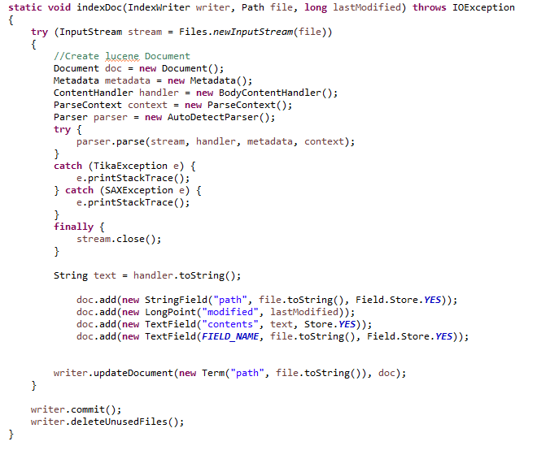

Search Classes in Lucene
The main search classes in Lucene are IndexSearcher, Query, Term, and Hits.

IndexSearcher
An IndexSearcher searches a document from an index. An index is opened in read only mode and uses its methods to return the search results. The results can be printed or sorted or listed.

Query
A query class is used for defining user queries. There are a number of query types in Lucene, the various query types are BooleanQuery, FilteredQuery, MultiTermQuery, PhrasePrefixQuery, PhraseQuery, PrefixQuery, RangeQuery, SpanQuery and TermQuery. The QueryParser class can automatically understand which type the user query belongs to.

Term
The term class represents the text in a document while searching. The term class takes two parameters, (a field and a text) the field is one in which the text will be searched. The term class is used for constructing the user query.

Hits
After the construction of a query, the IndexSearcher class searches the documents from the index. The results of the IndexSearcher class are pointed by the Hits class.

Scoring
Lucene scoring is fast and it hides almost all of the complexity from the user. Lucene scoring uses a combination of the Vector Space Model (VSM) of Information Retrieval and the Boolean model to determine how relevant a given Document is to a User's query. In VSM the more times a query term appears in a document relative to the number of times the term appears in all the documents in the collection, the more relevant that document is to the query. It uses the Boolean model to first narrow down the documents that need to be scored based on the use of Boolean logic in the Query specification. Lucene also adds some capabilities and refinements onto this model to support Boolean and fuzzy searching, but it essentially remains a VSM based system at the heart. In Lucene scoring is very much dependent on the way documents are indexed; the objects that are scored are the Documents and a Document is a collection of Fields. Each Field has semantics about how it is created and stored (i.e. tokenized, untokenized, raw data compressed, etc.). Lucene scoring works on Fields and then combines the results to return Documents. This is important because two Documents with the exact same content, but one having the content in two Fields and the other in one Field will return different scores for the same query due to length normalization (assuming the DefaultSimilarity on the Fields).

The Lucene Scoring Formula
Lucene's scoring formula computes the score of one document d for a given query q across each term t that occurs in q. The score attempts to measure relevance, so the higher the score, the more relevant document d is to the query q.

score (q,d) = sum t in q( tf (t in d) * idf (t)^2 * getboost(t in q) * getBoost (t.field in d) * lengthNorm (t.field in d) ) * coord (q,d) * queryNorm (sumOfSquaredWeights)

where

sumOfSquaredWeights = sumt in q( idf (t) * getBoost (t in q) )^2

This scoring formula is mostly implemented in the TermScorer class, where it makes calls to the Similarity class to retrieve values for the following. tf(t in d) – Term Frequency - The number of times the term t appears in the current document d being scored. Documents that have more occurrences of a given term receive a higher score.

Search Results
Once Lucene completes a search, the results are displayed in a very easy to use manner. A HTML page is generated with all the search results. The search results page consists of highlighting the search string and extracting the best fragments. This is all achieved by using the highlighter class supplied with Lucene.
The highlighter class is used to markup highlighted terms found in the best sections of a text, using configurable Fragmenter, Scorer, Formatter, Encoder and Tokenizers. The search results consist of a small fragment of the document containing the search string. The fragment that is extracted has the maximum number of occurrences of the search string and this is achieved by using the getBestFragment method. The getBestFragment method extracts the most relevant sections and the document text is analyzed in chunks to record hit statistics across the document.
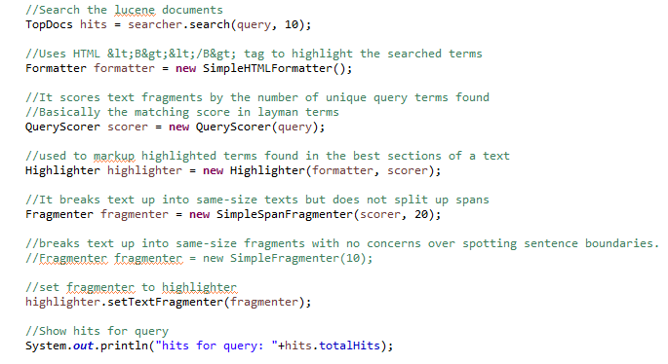

Formatter
After the best fragments are obtained they need to be formatted. The formatter processes terms found in the original text, typically by applying some form of mark-up to highlight terms in HTML search results pages There are two types of formatter available with this API. The GradientFormatter and the SimpleHTMLFormatter. A simple HTML formatter is used in this application, the simple formatter highlights terms by applying a pre-tag and a post tag.

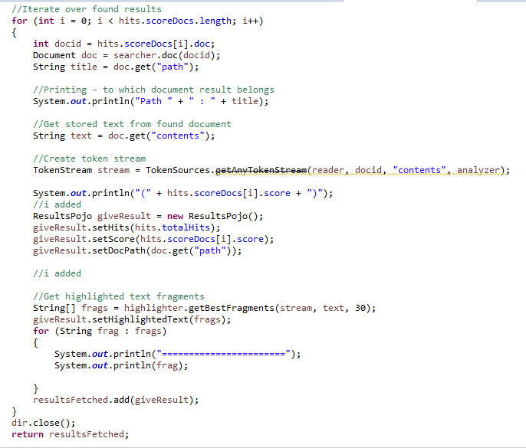

Results formatting

Results are available for the search queries in a very friendly manner, there are two ways how the results are displayed.
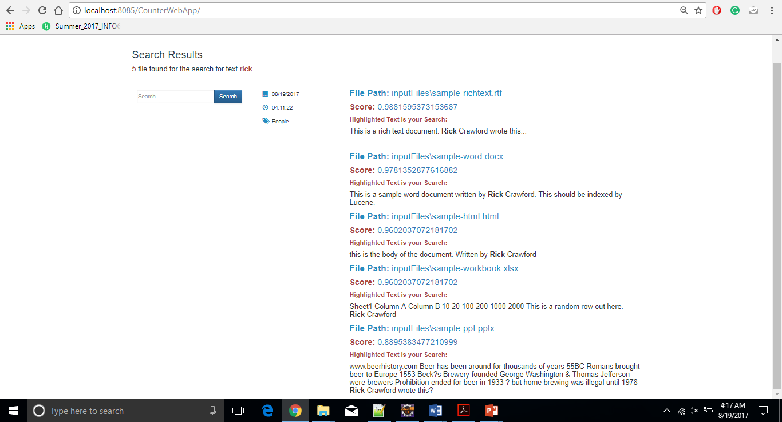

Scoring in Lucene (for Precision and Recall)

I am using treceval for precision, recall calculation. Treceval takes Relevance judgments and Result file as an argument to calculate the precision, recall. There is a similarity parameter in the result file.
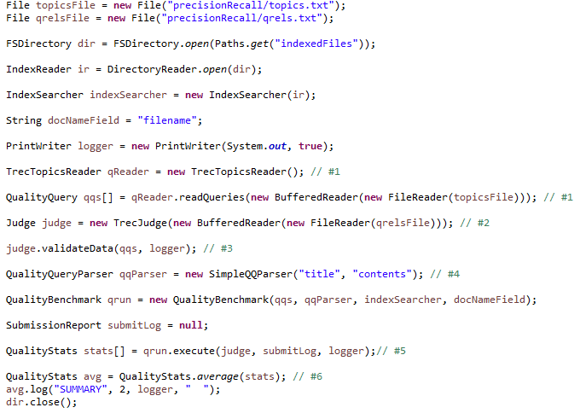
The score which is calculated by Lucene is equal to that similarity parameter.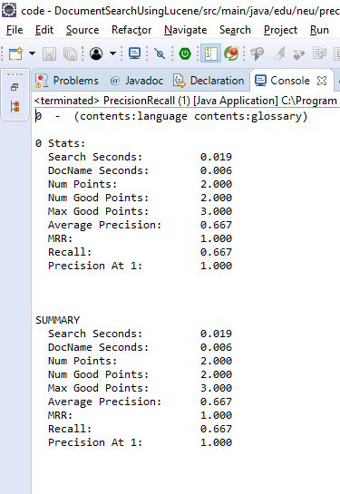

Steps to Run the Application

- Components:
  - Java
  - Apache Lucene 6.6.0
  - Apache Tika 1.13
  - Apache Tomcat 9
  - Spring
- To run:
- Open Java project
- Run LuceneWriteIndex.java as java application to generate the indexes
- Now run the project as webApp (run on server)
- Enter to keyword/text to search in the input text box
- Precision Recall:
  - Open qrels.txt file present in precisionRecall folder and all the files relevant to the search in the specified format
  - Open topics.txt file and edit the title to be the text to search
  - Now run PrecisionRecall.java file as java application
  - The output can be seen in Console.

REFERENCES

- “Lucene in Action” - Erik Hatcher, Otis Gospodnetic Manning Publications (December 28, 2004)
- “The Apache Software Foundation” – www.apache.org
- “Apache Lucene” - http://lucene.apache.org/
- “Information Retrieval” - http://en.wikipedia.org/wiki/Information_retrieval
- “Apache TIKA” - https://tika.apache.org/
- http://www.mkyong.com/spring3/spring-3-mvc-hello-world-example-annotation/
- https://github.com/arleyprates/lucene/tree/master/src/lucene/ri
- https://stackoverflow.com/questions/4322426/problem-with-precision-and-recall-measuring-in-lucene
- http://howtodoinjava.com/lucene/lucene-search-highlight-example/
- https://github.com/rickcrawford/lucene-example

